Architecture Recommendations
Draft M12, Final M24
Introduction
TODO: Write about the purpose of this document and how the document i structured to understand how it should be read.

Metadata driven, GSBPM 2
Types of services and clustering of function to services 4
Service Context 8
Sandboxing for exploration 9
Security 9
Performance 10
Resilient services and error handling 11
Versioning 11
Deployment 11
Containerization 11
Design principles for service autonomy 11
Integration patterns 11
Adapters and Separation of core logic 11
Multilingual support 12
Open source 12
Moving from legacy architecture to service oriented architecture 12
“DOCUMENT WIDE TODOS” 13

Metadata driven, GSBPM
Outline for chapter:
- GSBPM should not be interpreted as a linear model. The flow of information in the GSBPM often involves processes that are iterative, repetitive, parallel etc.
- Statistical production from a GSIM-perspective could be seen as a series/network of different types of data creating/processing/manipulation steps. Each step requires different types of GSIM-objects and the result from the step are GSIM-objects that in turn are used by other steps.

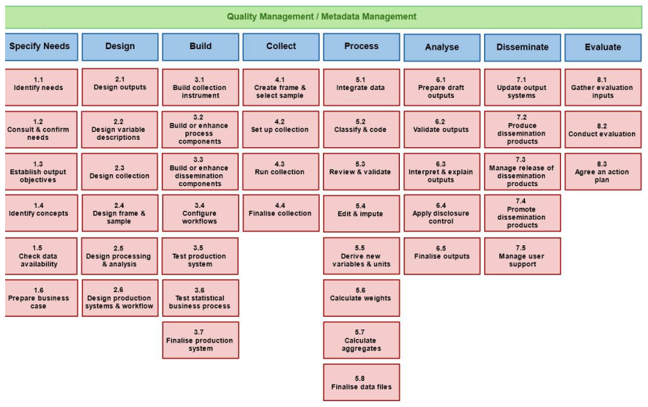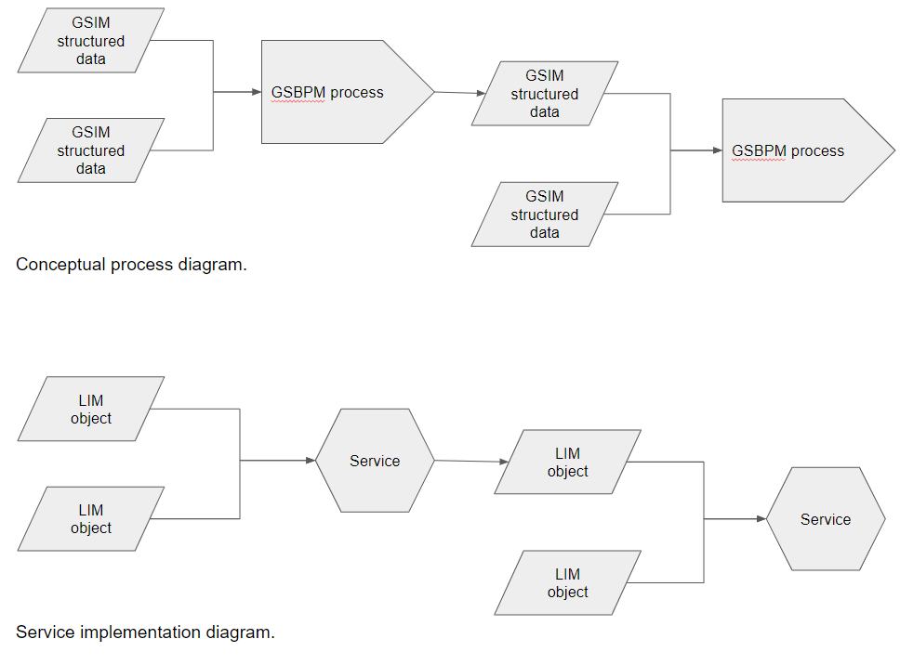

- Different names exists for the lower levels of work in statistical production. For steps closer to the GSBPM-phaze Process it will in many cases be a specific method that should be performed but for other GSBPM-phazes it could be described as a sub process, an activity or a task.
- In this document we use the word functionality to describe the conceptual level of these types of steps.
- GSIM->Functionality->GSIM
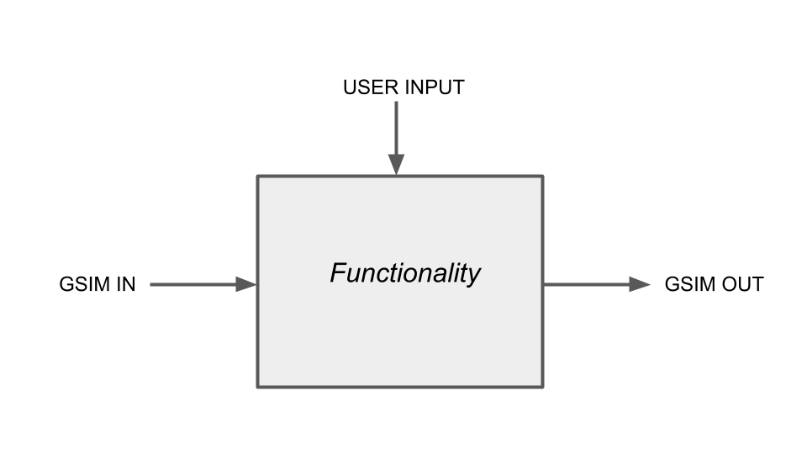
- Some functionality can be automated while others involve user interaction
- What triggers a functionality can be that some GSIM-information becomes available or that a user decides to perform the functionality
- The structure of how different GSIM-objects are related decides in which order different functionality must be performed due to what GSIM-objects are needed to perform the next functionality. For example - the functionality of error localization cannot be performed before the Dataset that should be used is available.
- In order to go from the conceptual level of functionality to something technical we need to implement some form of it-system
- From the CSPA-standard we have a relatively broad definition of Service but later in the document we describe how this document makes use of words such as Services, Applications, Systems, Code, Functions etc and that they can be seen as different forms or different levels of technical implementations for a Functionality

Types of services and clustering of functions to Systems/applications

Outline for chapter:

- In this chapter we will try to define how the different types of service can be composed of clusters of functions.
- The definition of services from CPA for three types of services:
  - Process service
  - Information service
  - Utilityservice
- A service can be composed by a cluster of functions (service=sum(f)). These services can be of different types. Some are more technical services made up with code that makes up a service. Others are made up by configurations that can be accessed in build or runtime.
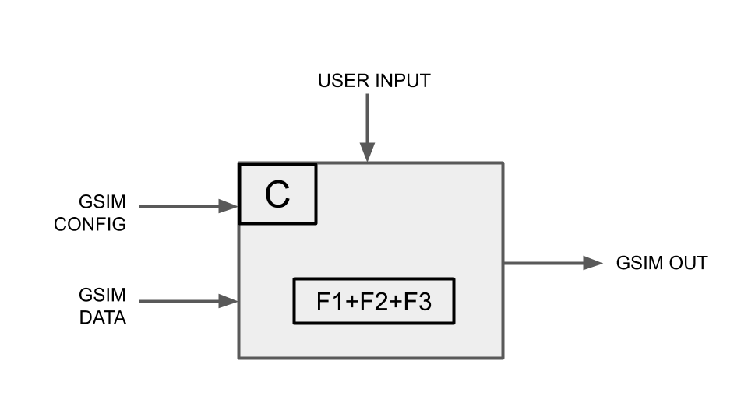
- Functions and services can be of different sizes that can be clustered to fulfill a functional requirement. A function in this sense is bigger than the core functionality.
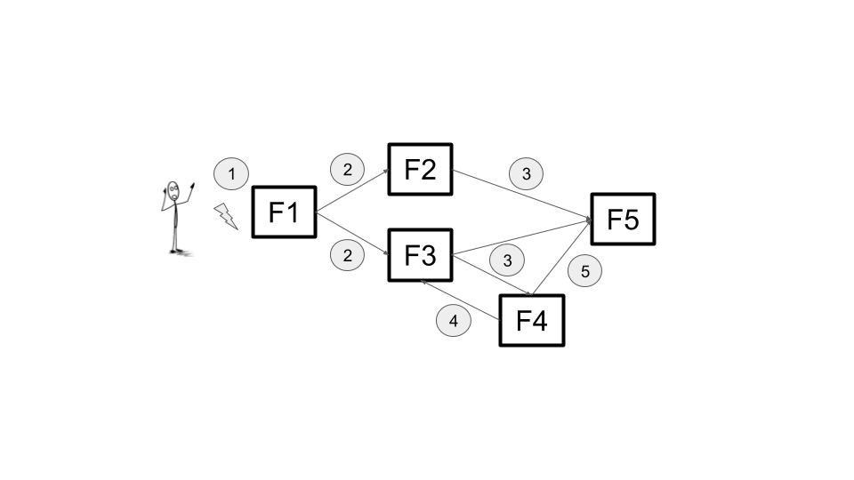
- A system/application can be composed by multiple functions or services. This means that depending on how a system/application is composed the workflow for the CSPA role configurer can differ depending on the composition of a system/application.

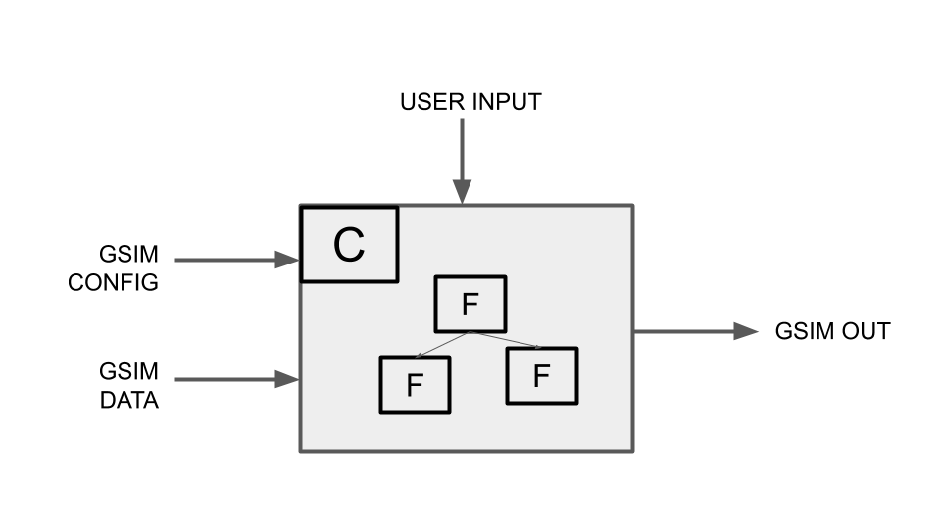

Implementing and encapsulating functions
Outline for chapter:
- A function must be implemented in some technical framework(.Net core, R, Neo4J).
- Different ways of encapsulating these technical frameworks.

Cores and adapters
Outline for chapter:
- Compile-time

Function as a service
Outline for chapter:
- Describe how the concept of Function as a service supports implementation.

Containerization
Outline for chapter:
- One container
- Set of containers (docker compose…)

System/application Context
Outline for chapter:
- Explain the concept of system (a.k.a. application)
- Systems can be used within different contexts
  - Basic contexts from an ALM-perspective: Dev, Test, Prod
  - To use a system in a specific context, the system should be deployed to different environments
  - Within production, different business contexts exists
    - Different Statistical programs
      - Statistical program cycles
    - Iterative design of production (could be while production is running or changes to next statistical program cycle) requires an organized way of managing
  - Different environments could be created for production to separate the business contexts
  - The purpose for creating different environments could be due to performance, security, easy versioning of systems, keeping production environments sanitized with regards to old data/information etc
  - Different approaches to setting up environments/systems
    - Gen 1 - All Statistical Programs run in the same environments - the same system instance is used by all Statistical Programs
    - Gen 2 - Manually creating different environments for different Statistical Programs or Statistical Program Cycles
    - Gen 3 - Automatically generating environments or instances of systems based when a new Statistical Program or statistical program cycle is created
    - Gen 4 - Continuous integration/Continuous Deployment or deploying functions

- A system/application can exist in different versions in different production environments. TODO: Add image showing this.

Sandboxing for exploration
Outline for chapter:
- Chapter is not directly architecture but is worth mentioning.
- TODO: Sandboxing for “turning the knobs” as a different chapter? Or broaden this...

Security
Outline for chapter:
- There are many ways to handle security. Discuss how security can be implemented in different layers.
- Zero trust can be implemented in different ways. Data at rest, data in transit.
- Capability based security (Tokenbased)
- Mandatory Access Control (MAC)
- Authentication Before Application
- Boundaries first container style
- Describe security from the perspective of CSPA roles, configurer och user.

Performance
Outline for chapter:
- There are many types of dimensions for handling performance.
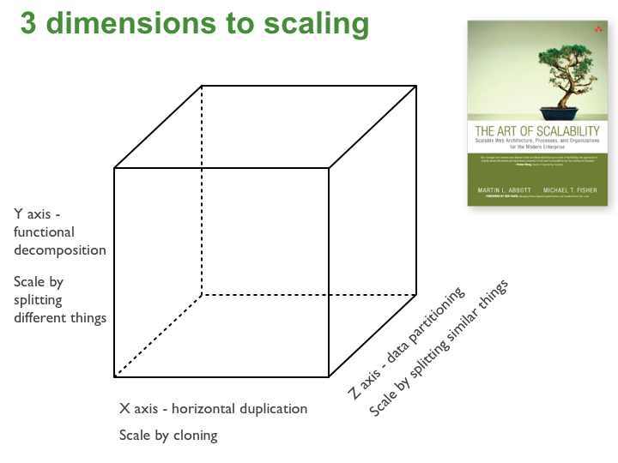
- TODO: Describe the different dimensions.

Resilient services and error handling
Outline for chapter:
- A runnable service must be able to handle internal crashes and should have functionality to recover from a crash where it applicable.

Versioning
Outline for chapter:
- There are different kinds of versioning in different context.
  - Service(code)
  - GSIM structure
  - Information object instance
- Describe this types.

Deployment
Outline for chapter:
- In this chapter we will summarise the features above. We will describe different types of deployment that supports different requirements and features. Refer to the work from WP1 that norway have done.

Containerization
Outline for chapter:
- Describe how containerization can help us to achieve some of the non functional requirements.

Design principles for service autonomy
Outline for chapter:
- Have a discussion about some of the key principles for service autonomy and shareability.

Integration patterns
Outline for chapter:
- Time and chaining of functions into sequences as architectural driver
- “Storage is not a solution for integration”
- Point to point, event driven, orchestration
- Multiple instances of services

Multilingual support
Outline for chapter:
- Chapter is not directly architecture but is worth mentioning.

Open source
Outline for chapter:
- Chapter is not directly architecture but is worth mentioning.

Moving from legacy architecture to service oriented architecture
Outline for chapter:
- Selective decomposition.
- Enable release of information ownership.

“DOCUMENT WIDE TODOS”
- How to link content to CSPA 2.0 without repeating ourselves.
- Deeper analysis on how to make correct choices including pros and cons given a context.
- Example on UDB, a service that could not be instantiated per context.
- Create pictures of all the hand drawn whiteboard image.

